# EEE109 Lab 3

# Frequency Response of A BJT Amplifier

**Student IDs:** *1931254*

**Submission date:** *21/12/2020*

### *Abstract*

*Frequency response is one of the most important property of amplifiers. The amplifiers have been designed in the frequency range that they must deliver a reasonable and constant level of gain. The frequency response depends directly on the components and the architecture chosen for the amplifier. The objectives of this experiment are: calculate the lower and upper cutoff frequencies of a common emmitter amplifier and common collector amplifier, studying the frequency response range of the low and high. In this experiment, several measurements will be conducted at first like the values of the resistors of the common emitter and common collector amplifiers circuits. After that, a simulation using LTspice will be conducted to measure the related values and frequency response.*

### Introduction

The experiment engages in the frequency responce of BJT transistors from low to high frequency. Because we have considered bypass capacitors and coupling capacitors as short circuits to the signal voltage and open circuit to dc voltage, the effect of internal capacitances in the bipolar transistor are neglected. Therefore, in the experiment, we will investigate the frequency response from low to high frequency.

The objectives of the experiment can be seperated into four parts. Firstly, by calculating the values of the resistors for the common emitter and common collector amplifiers circuits, the understanding of BJT transistors should be strengthened. Secondly, the lower and upper cutoff frequencies of a common-collector and common-emmitter amplifier should be measured. Thirdly, the amplifier frequency response measurements should be simulated by using LTspice. Lastly, based on the simulation, investigate the frequency response in low to high frequency range.

### Theory

Because we have considered bypass capacitors and coupling capacitors as short circuits to the signal voltage and open circuit to dc voltage, the effect of internal capacitances in the bipolar transistor are neglected. Considering the amplifier response in the entire frequency range, the figure of amplifier gain versus frequency is as follows.

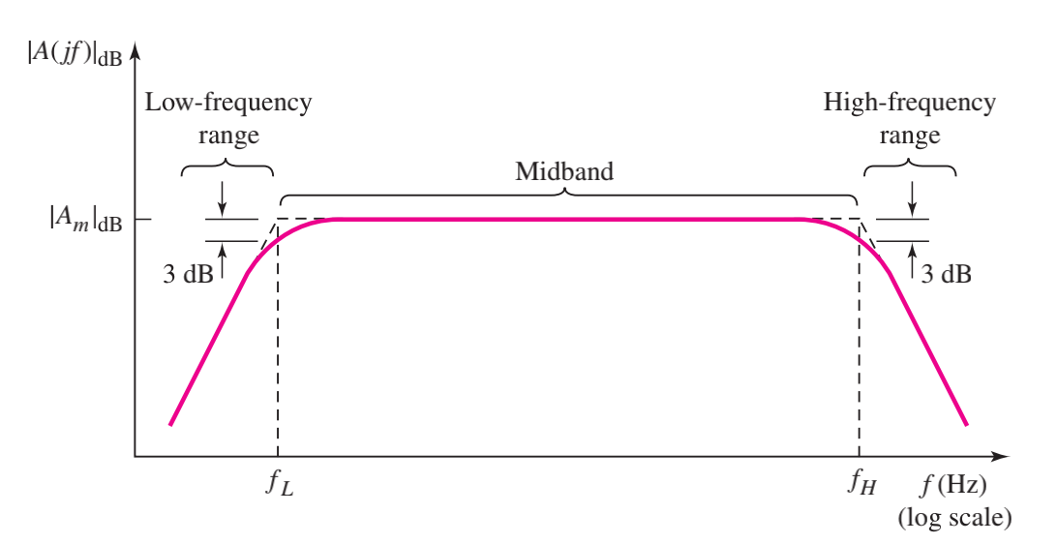

Figure 1: Amplifier gain versus frequency [1]

The figure shows that at the high frequency and low frequency area, The gain variation of an amplifier is specifically related to frequency.

In the low frequency area, capacitive reactance () is inversely proportional to frequency (f) and capacitance (C) as the equation shows:

From the equation, it is easy to conclude that capacitive reactance is inversely proportional to capacitance and frequency. When the capacitance is constant, the capacitive reactance decreases with the frequency increasing.

For the high frequency area, the inductive reactance () is inversely proportional to frequency (f) and inductor (L) as the equation shows:

From the equation, it is easy to conclude that inductance is proportional to inductance and frequency. When the inductance is constant, the inductive reactance increases following the increase of frequency.

When the capacitive and inductance reactance increases, the current of the circuit will decrease, and amplifier gain will decrease. So that is the reason why the amplifier gain decreases in the high frequency area and increases in the low frequency area.

### Circuit Design

In the first part of the experiment, a circuit to calculate the value of current gain () of the transistor should be created. And the components of the circuit should be a NPN transistor 2N3904, a dependent current source in a 0 to 40 range and a DC voltage source in a 0 to 10V range. The circuit to measure current gain () is as follows.

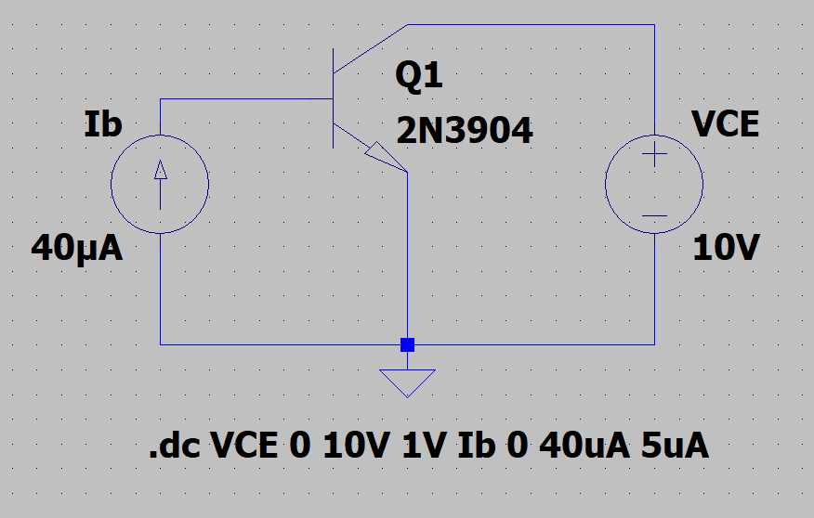

Figure 2: Measurement of current gain ()

In the second part of the experiment, a circuit to calculate the values of several resistors and investigate the frequency response of the common emitter amplifier should be created, and a BJT 2N3904, some resistors such as RL=3.9 k, Rc, Re, R1, R2 according to calculations, one 47 F capacitor, and two 1F capacitors should be used in the circuit as follows.

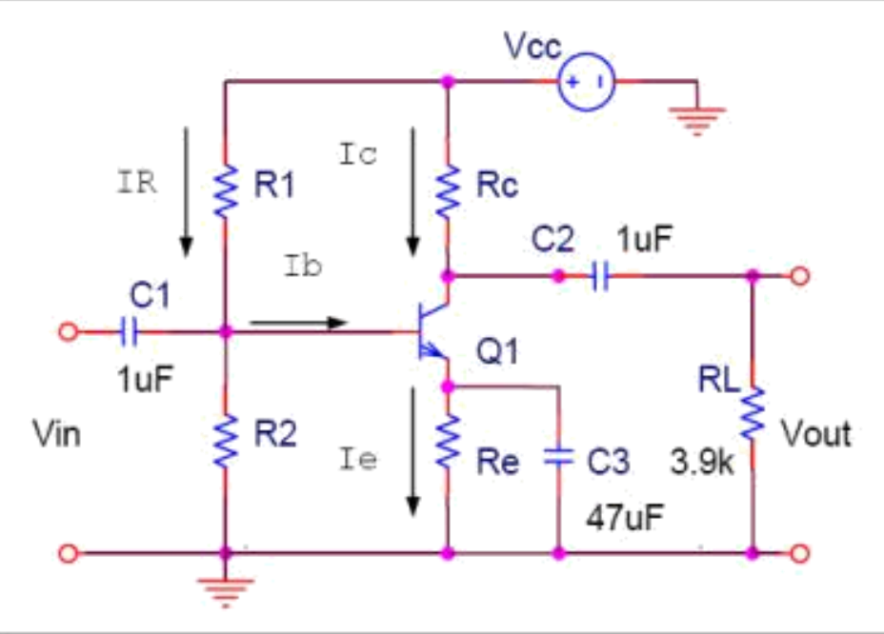

Figure 3: The common emitter amplifier

In the third part of the experiment, a circuit to calculate the values of several resistors and investigate the frequency response of the common collector amplifier should be created, and a BJT 2N3904, some resistors such as RL=3.9 k, Rc, R1, R2 following calculations, a 1F capacitors, and a 47 F capacitor should be used in the circuit as follows.

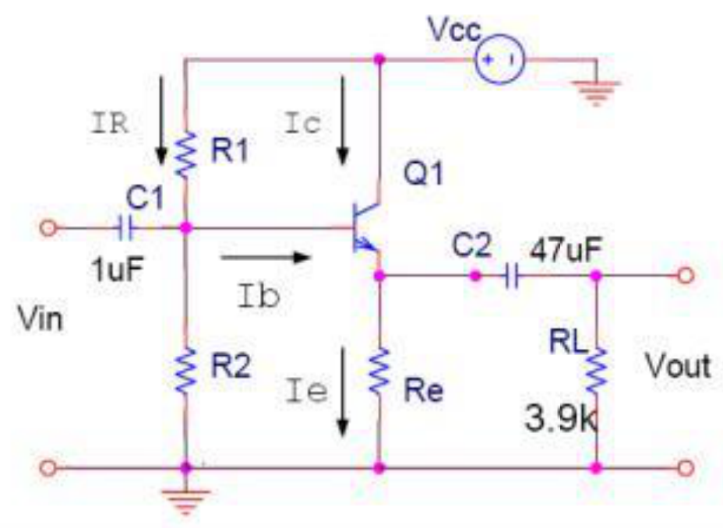

Figure 4: The common collector amplifier

### Experimental Method

4.1 Find of the Transistor

In the first part of the experiment, a circuit as shown in the last part should be created at first. Moreover, the value of should be set to 0, 5, 10, ..., 40 , and the value of should be set to 0, 1, 2, ..., 10V as following.

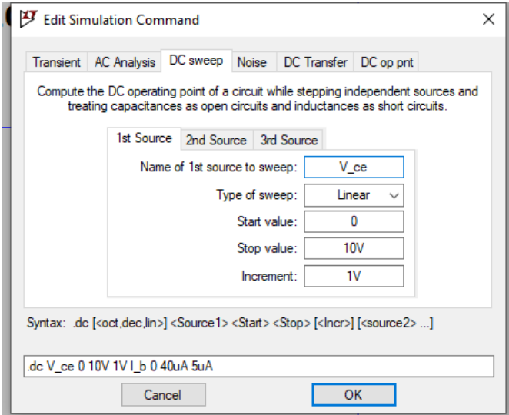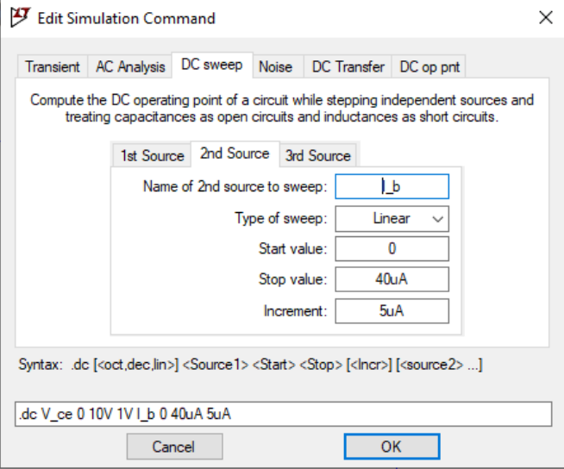

Finally, based on the simulation of the LTspice, calculate the value of current gain of the BJT transistor.

4.2 Common Emitter Amplifier

In the second part of the experiment, the given equations as follows should be used to calculate the values of Rc, Re, R1, R2.

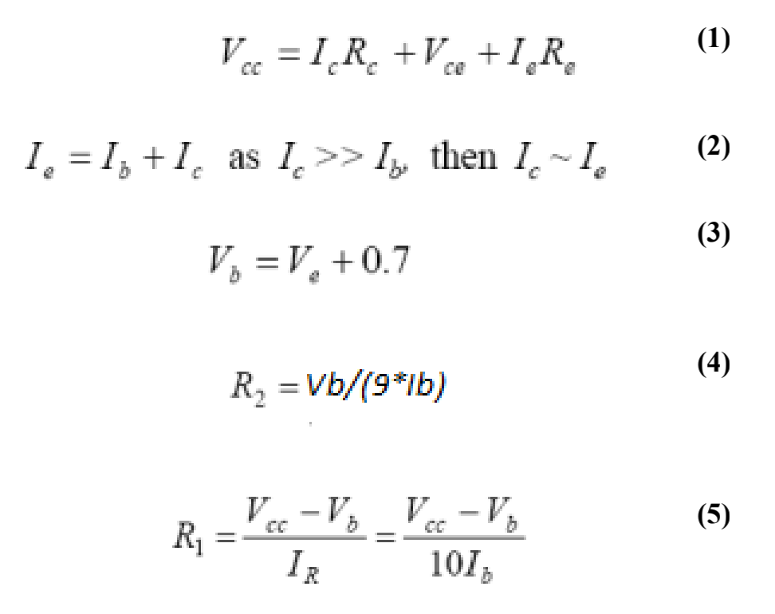

And then the circuit should be simulated on the LTspice to show the voltages and bias currents on the schematic.

At last, the gain frequency response for the amplifier from 10Hz to 10 GHz and the 3dB point should be obtained.

4.3 Common Collector Amplifier

In the last part of the experiment, the given equations as follows should be used to calculate the values of Re, R1, R2.

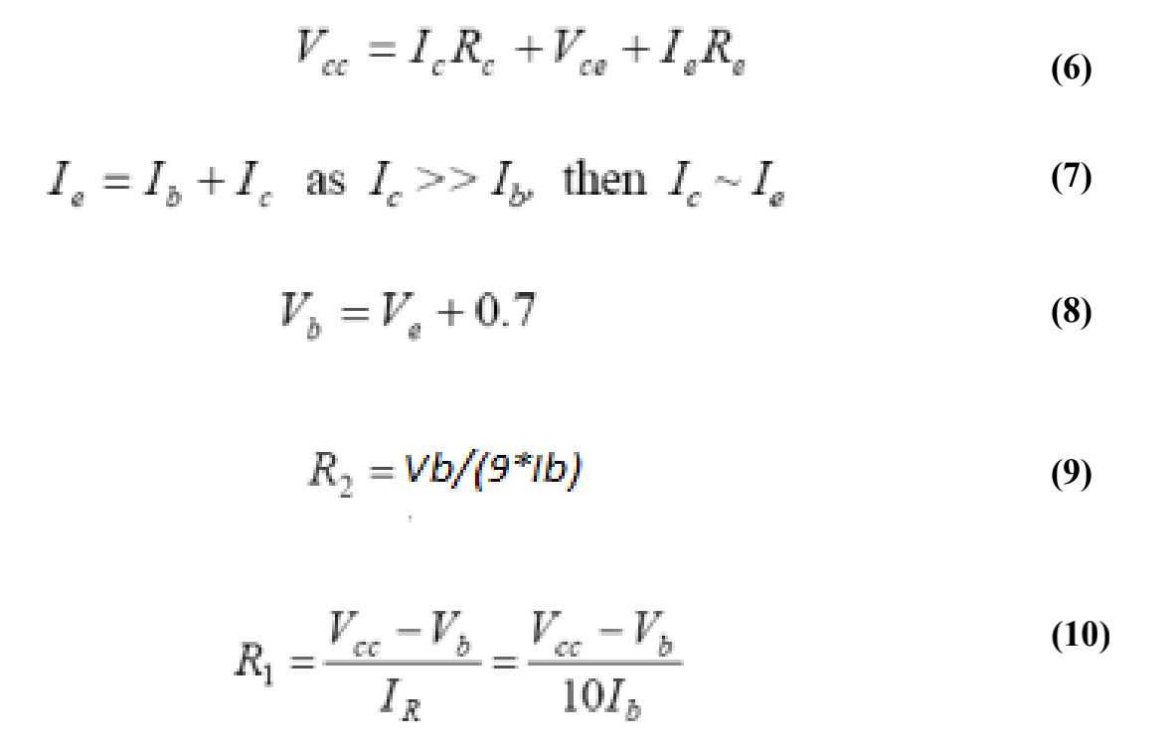

And then the circuit should be simulated on the LTspice to show the voltages and bias currents on the schematic.

At last, the gain frequency response for the amplifier from 1Hz to 300 GHz and the 3dB point should be obtained.

### Results and Calculation

5.1 Find of the Transistor



Circuit 1

For the circuit above, we used LTspice software to simulate the consequense.

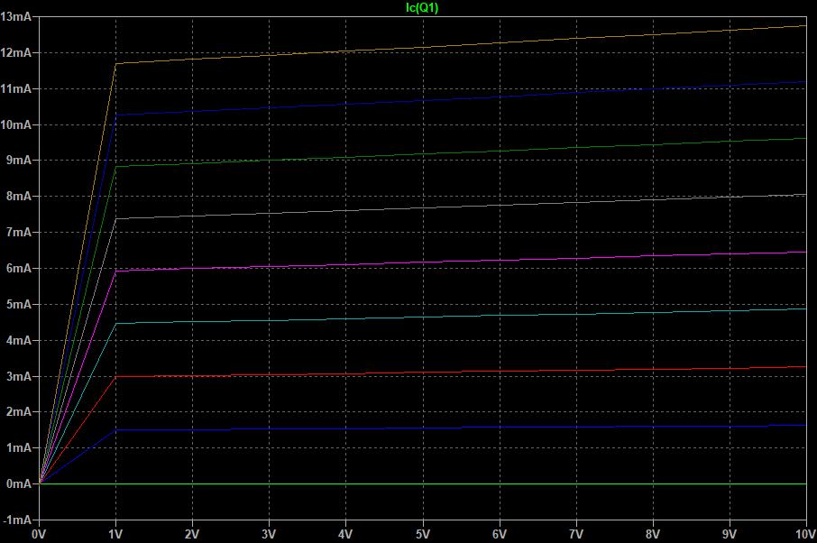

Figure 5: The simulation of Find of the Transistor

It can be seen from the figure that is close to 5mA at 5.4mA, and the corresponding collector voltage () is 5V. In the meantime, is nearly 17.5A. So, .

5.2 Common Emitter Amplifier

At the beginning, Kirchhoff’s voltage Law, Kirchhoff’s current Law and Thevenin equivalent circuit should be applied such as , , ,, to abtain the values of Rc, R1, R2 and Re. Finally, we got the answer: R1 51234.6Ω, R2 11659.8Ω, Rc 800Ω and Re 200Ω.

After the calculation, the circuit was filled up with the calculated values of resistors as follows.

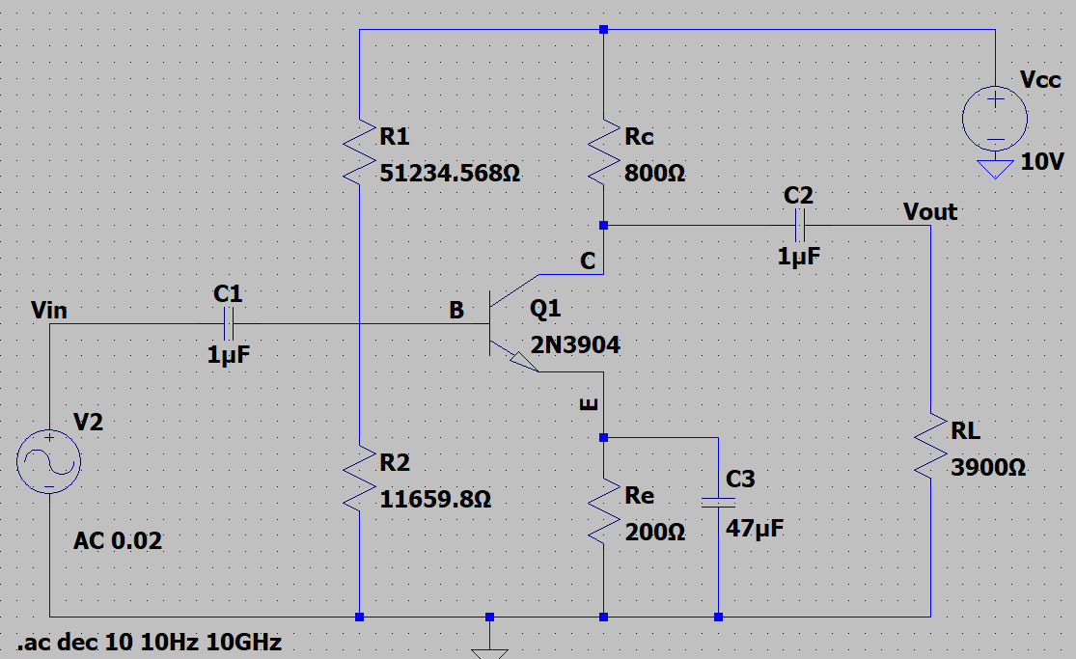

Circuit 2

The bias currents and voltages are shown below.

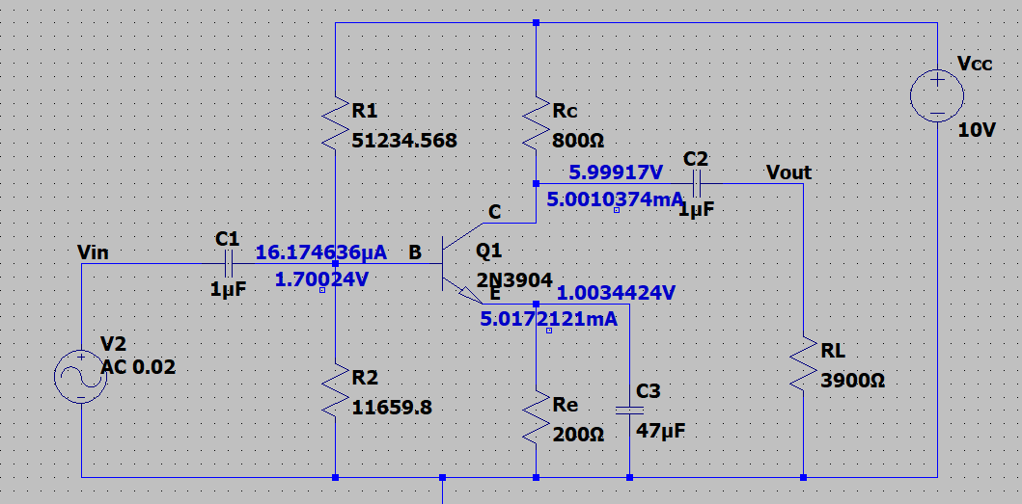

Figure 6: All bias currents and volages

The voltage gain of the common emitter amplifier is shpwn below.

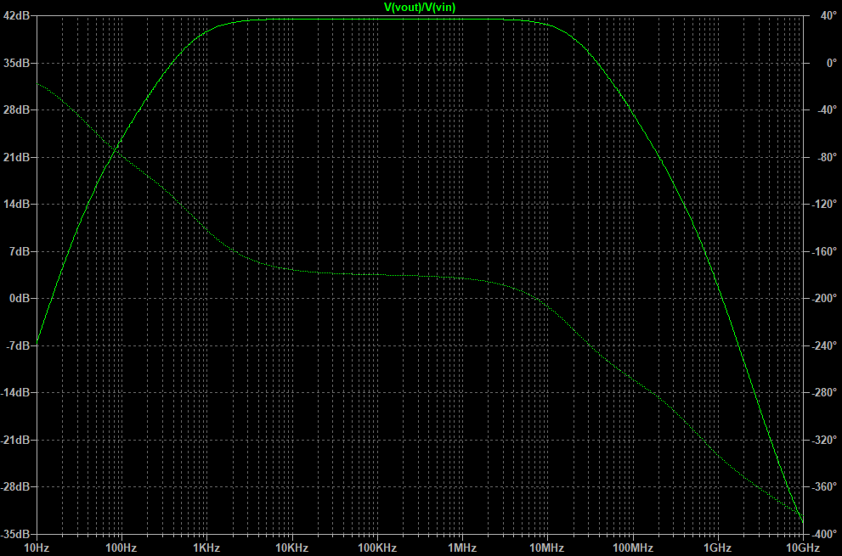

Figure 7: Voltage gain of the common emitter amplifier

From figure 7, it is easy to find that the maximum midband gain is 41.5dB. Therefore the 3dB points are 38.5dB as two figures below.

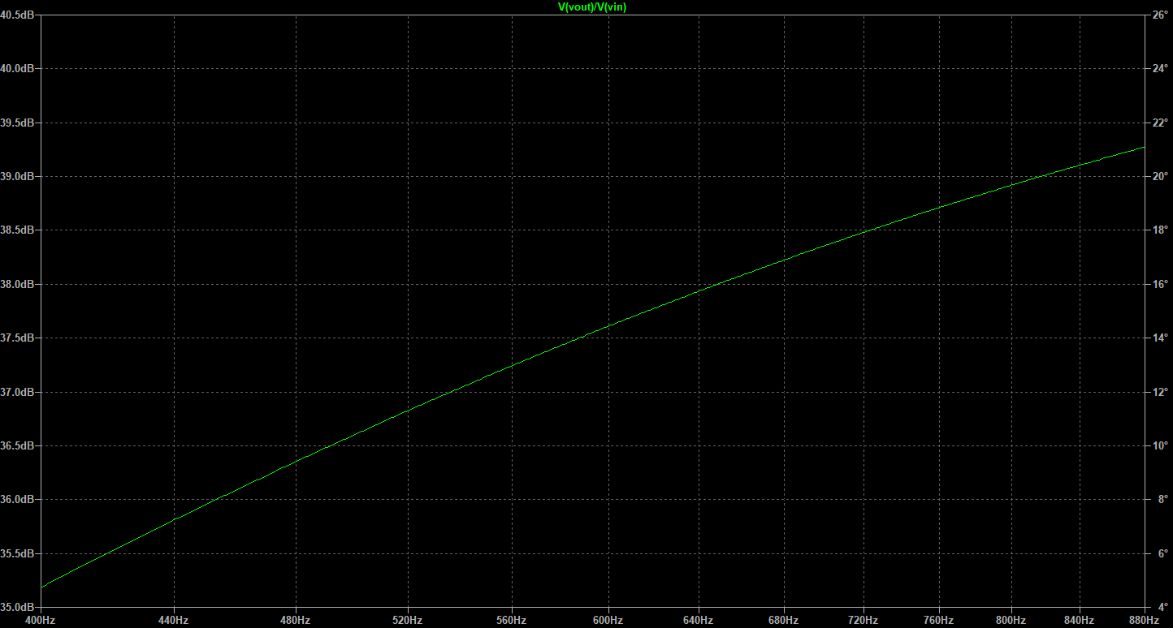



Figure 8: The first 3dB point

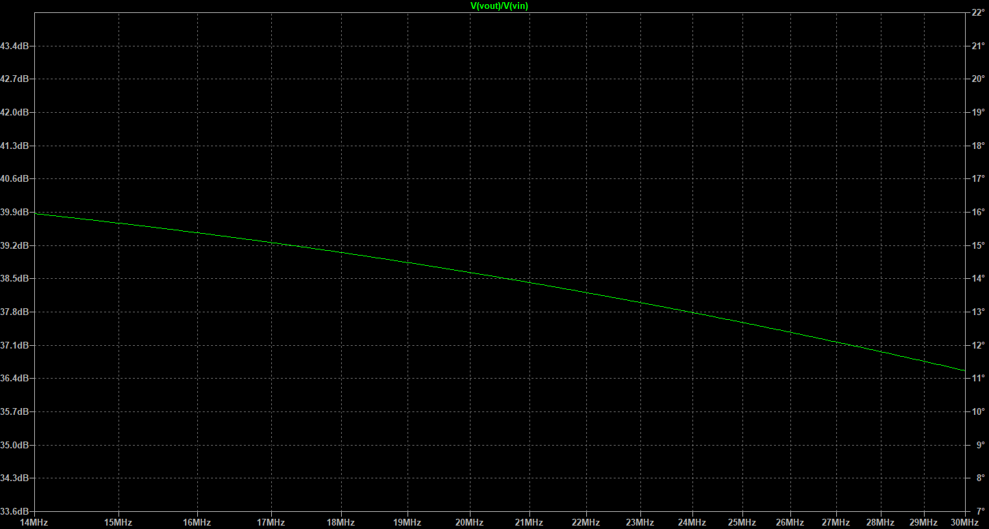



Figure 9: The second 3dB point

From two figures, it is easy to find that the values of these two cut-off frequencies are almost 733Hz and 20.6MHz. To be short, and . So the bandwidth of the common emitter amplifier is 0.6MHz.

5.3 Common Collector Amplifier

At the beginning, Kirchhoff’s voltage Law, Kirchhoff’s current Law and Thevenin equivalent circuit should be applied such as , , ,, to abtain the values of R1, R2 and Re. Finally, we got the answer: R1 26574Ω, R2 39140Ω, and Re 1000Ω.

After the calculation, the circuit was filled up with the calculated values of resistors as follows.

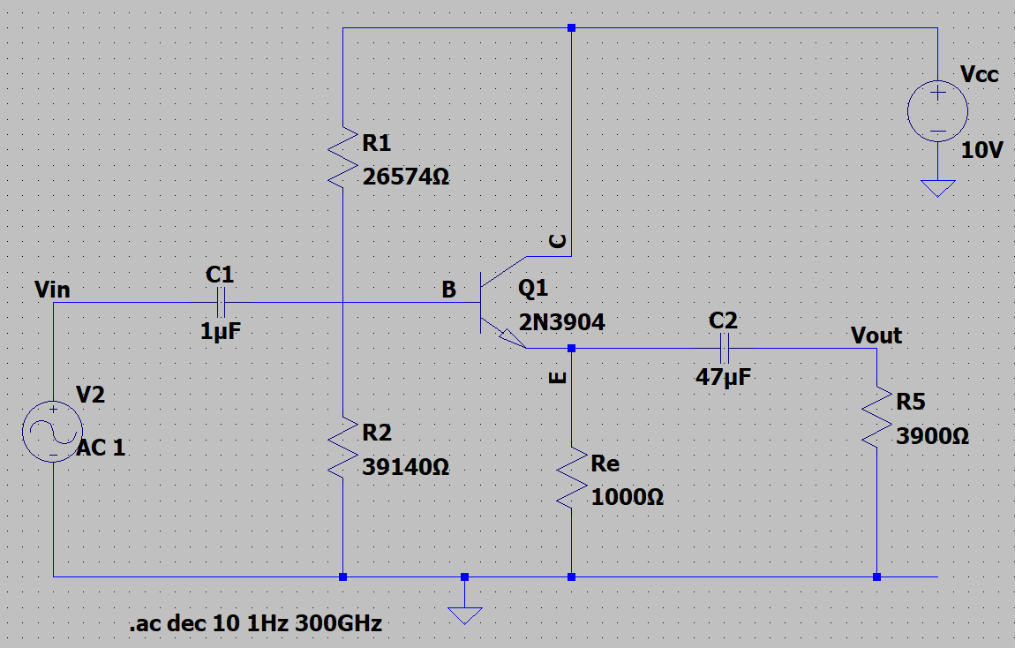

Circuit 3

The bias currents and voltages are shown below.

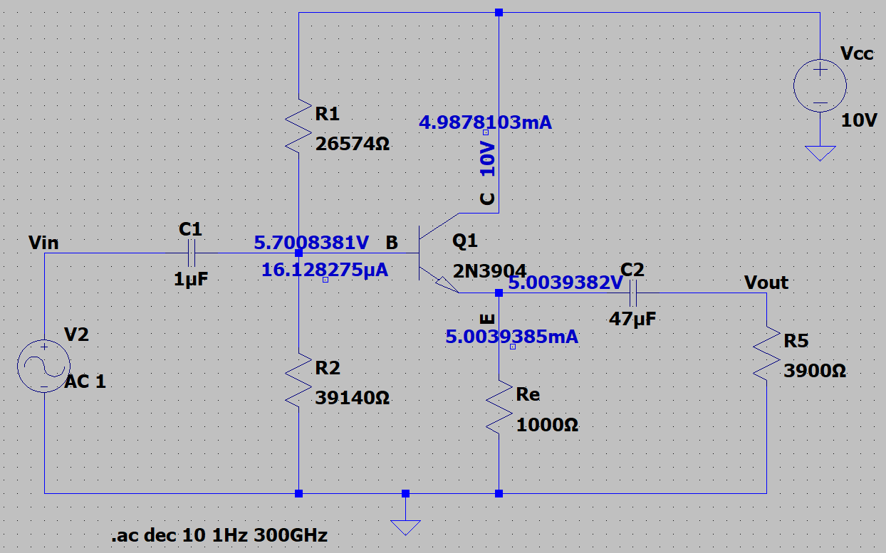

Figure 10: All bias currents and volages

The voltage gain of the common emitter amplifier is shown below.

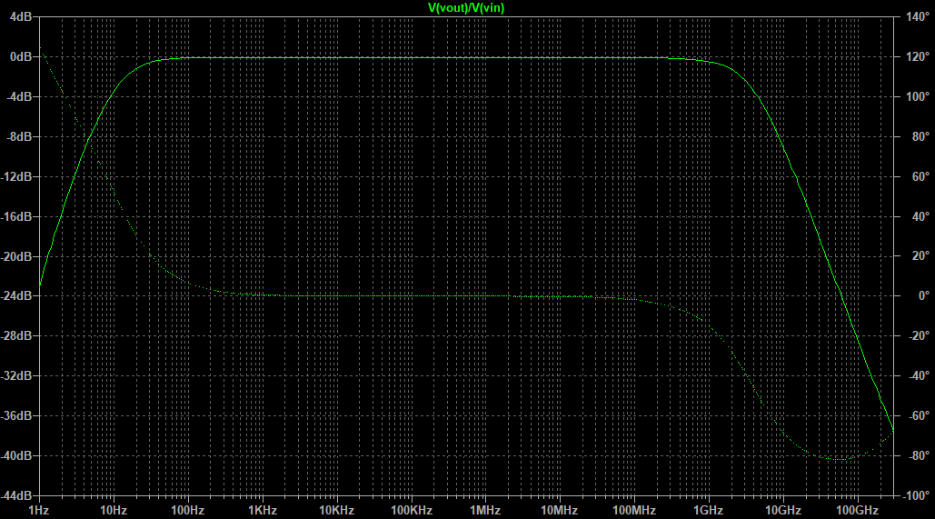

Figure 11: Voltage gain of the common collector amplifier

From figure 11, it is easy to find that the maximum midband gain is 0dB. Therefore, the 3dB points are -3dB as following two figures below.

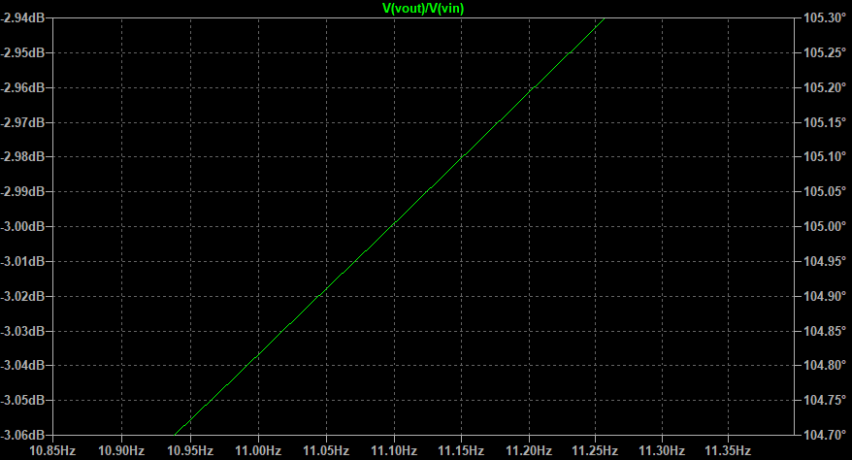



Figure 12: The first 3dB point

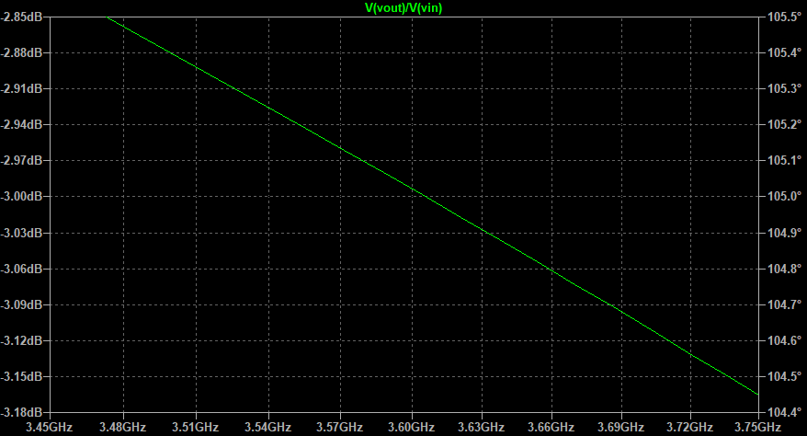



Figure 13: The second 3dB point

From these two figures, it is easy to find that the values of these two cut-off (-3dB) frequencies are almost 11Hz and 3.6GHz. To be short, and . So the bandwidth of the common emitter amplifier is 3.6GHz.

### Discussion

There are two different sorts of error in this experiment. The first is systematic error, where the data simulated using the software does not represent the actual values completely accurately due to the different division values. The second is experimental error, which is also hard to avoid since human observations vary and readings are not the same. If we want to improve the experiment, we can only reduce the error by making several measurements and then getting the average.

For further experimentation, we are able to replace each capacitor with ones that are larger and smaller than the former ones in this experiment and measure the response curve by LTspice again.

### Conclusion

In the low-frequency range, where f < , the gain decreases with the frequency decreasing. In the highfrequency range, where f > , the gain decrease with the frequency increasing. However, in the midband range, the gain is approximately constant, which will be used for its effectivity.

By comparing the frequency response of the two variations responses on common emitter amplifier and common collector amplifier, it is easy to find that the bandwidth of the common emitter amplifier is much greater than the common collector amplifier.

### References

[1] D. A. Neamen, *Microelectronics: Circuit Analysis and Design,* New York, 2010, pp. 470-485.